Vision for SensorWeb services at the European Environment Agency

Title | Vision for SensorWeb Enablement services at the European Environment Agency
Date Issued | 2011-10-28
Publisher | European Environment Agency (EEA)
Description | Describe the general system architecture including datamodel, SOS Extension, Biztalk integration, ETL, member states integration, existing dataflows, integration into Eye on Earth etc. Also to include specific use cases.
Contributor | European Environment Agency (EEA); [Atkins Danmark a/s; Con terra, 52 North, Umweltbundesamt, Austria]
Format | DOC
Language | En

Contact
Peter Kjeld, EEA (peter.kjeld@eea.europa.eu)





Revision history

Version | Date | Author | Change
DRAFT1 | 2011-10-28 | Jon Maidens | First draft laying down structure

Table of Contents
1. Introduction 5
1.1 Objectives 6
1.2 Key terms 6
1.2.1 Observation and Measurement (O&M) 6
1.2.2 SensorWeb Enablement (SWE) 6
1.2.3 O&M in combination with SOS 7
1.2.4 Open Geospatial Consortium 7
2. Architecture 8
3. Use cases 10
3.1 Information provider 10
3.2 Information consumer 10
3.3 Eionet 10
3.4 European Environment Agency 10
3.5 Global monitoring 10
4. Business cases 11
4.1 Information provider 11
4.2 Information consumer 11
4.3 Eionet 11
4.4 European Environment Agency 11
4.5 Global monitoring 11
5. Output integration 12
5.1 Specific clients 12
5.2 ArcGIS Server SOS extention 12
5.3 EyeOnEarth 12
6. Linkages to INSPIRE and reporting mechanisms 13
7. Document references 13

Introduction
The demand for near real-time data flows is increasing. The EEA needs to stimulate the flow of environmental data, and increase possibilities for use, in providing real-time indicators of the state of the environment and in-situ monitoring and satellite observation.
This vision paper proposes that through the EEA-driven adoption of the Sensor Web Enablement (SWE) protocol these goals can be addressed. SWE is a set of open standards for interoperable communication provided by the Open Geospatial Consortium (OGC). The standards are directed at the transfer and the communication of environmental observations and data among distributed systems.
Through implementation of one open standard, which is thematically independent, a high level of interoperability can be achieved between data providers. This translates in to a benefit of increased and improved access to environmental data for the public, industry and government, which falls in line with the EEA’s remit under SEIS and INSPIRE. Also EEA can cement is position as the data and information node for Europe. Furthermore, using an established open standard is targeted at costs of setting up data flows by recommending an architecture which can be implemented across different themes and levels.
The EEA can lead the way in the implementation of the protocol through enabling a SWE data flow for an existing data flow as a proof of concept. The building blocks are already there and with a carefully planned balance of targeted implementation, demonstration and stakeholder community building over the next 5 and 10 years, the EEA can promote a viable data sharing architecture.
During the last years, provision and use of environmental data in near real time has become more and more important. Especially for the EEA, which receives data from a large number of data providers from all its member states (i.e. multiple data providers per member state), exchanging sensor data in a timely manner becomes a significant challenge. Today, a large number of proprietary data formats and data access mechanisms (e.g. FTP, specific web services, etc.) cause a significant overhead for collecting and providing near real time sensor data. Each new data source with its specific data format and interface has to be adapted by the EEA infrastructure individually as to be able to integrate its data.
Thus, EEA is aiming at establishing an interoperable, open and service oriented architecture like the OGC’s Sensor Web Enablement (SWE) framework of standards as to ease both the fusion and redistribution of near real time sensor data. The main advantages of this architecture are:
- The SWE architecture provides open and interoperable data formats for providing access to sensor data (i.e. OGC Sensor Observation Service), encoding sensor data (i.e. OGC Observations and Measurements) and encoding the relevant sensor metadata (i.e. OGC Sensor Model Language)
- The OGC SWE architecture is not vendor specific. Instead these open standards can be implemented by any software provider. Thus, EEA does not need to prescribe certain software tools to the member states for providing their sensor data. It is sufficient if the member states rely on SWE compliant software tools. Alternatively also existing software infrastructures could be adjusted to support SWE with relatively low effort.
- The SWE framework is domain independent. This means that EEA would be able to handle water related data, air quality data or any other kind of in-situ measurement with the same infrastructure.
As a result we see the application of SWE and SOS as beneficial in two ways: On the one hand it serves the EEA as to establish as SOS platform for providing access to their near real time environmental data. On the other hand, EEA will be able to support member states in providing their data to EEA through standardised interfaces and thus reduce the efforts for collecting sensor data from its member states.
As to establish this framework EEA strives for:
- adapting and integrating the SWE standards (i.e. SOS, O&M and SensorML) into EEA’s infrastructure and workflows using BizTalk and ArcGIS Technology.
- working with member states as to agree on common profiles for the existing standards; this will increase the interoperability between member states and EEA and further reduce the complexity of SWE implementations.
- working with the standards community as to improve existing standards and to adapt EEA’s concepts according to new developments in the standards community.
- supporting member states in adapting the standards by providing software, documentation, and advice.

Objectives
The overarching objectives for this vision are:
- Develop a model technical architecture for SOS information flows
- Integrate EEA dataflows using SOS services
- Establish connections to relevant OGC working groups to ensure consistency within the SWE standards
- Advise Member States on SOS implementation
- Develop best practice guidelines

Key terms

Observation and Measurement (O&M)
While INSPIRE is foremost a Spatial Data Infrastructure, several of the Annex Themes have been specified so that their scope, in addition to the basic spatial information, includes measured, modelled or simulated data. The ISO 19156 standard on Observations and Measurements (O&M) was designed for this explicit purpose, and thus shall be used in INSPIRE to cover these requirements.

SensorWeb Enablement (SWE)
Sensor Web Enablement (SWE) is an Open Geospatial Consortium (OGC) initiative for interoperable communication especially designed for the transfer and the communication of environmental observations and data. The initiative is a framework covering several standards and specifications.
SWE does not necessarily imply an observation from a single mechanical or electronic device; the important criteria are that observations have a relation to time and place. It could also be a set of observations related to rivers, regions, counties or Europe as a whole. We are able to define our data sources at the desired geographical level and make that data available in the same format, regardless of the geographical level.
SWE defines a data model which provides the basic structure of how data should be communicated. In addition, services are available which allow us to work with the environmental data from a particular data source, e.g database or sensor. The protocol suite supports access to data, aggregation of data, alerts when measured values are changing or exceeding a threshold. The suite also supports other procedures regarding controlling sensors and data collection. Real-time and archived observations from these sensors and models are accessible in standard encodings, through standard interfaces, and are capable of being geo-referenced and processed on-demand without a priori knowledge of the underlying sensor system.
For the purposes of live data flows, we are concerned with only two of the above mentioned aspects of SWE and those are the fundamental data model and the Sensor Observation Service (SOS).
The OGC is behind the concept of Sensor Web Enablement and a key criteria for the EEA is the support of open standards. Importantly, the SWE effort involving OGC members in developing the global framework of standards and best practices is in continual progress, and therefore EEA can influence the formulation of the standards to include its needs within the broader application of SWE.

O&M in combination with SOS
SOS is a technical implementation of the O&M standard etc.

Open Geospatial Consortium
The EEA will ensure that these finding, requests and suggestions of the project are brought into the relevant OGC Working Groups. The following SWE related OGC working groups will be within the focus of work:
- Sensor Web Enablement Domain Working Group (SWE DWG): This working group deals with the general SWE architecture and is the ideal place for representing the goals and requirements of EEA with regard to SWE
- Sensor Observation Service 2.0 Standards Working Group (SOS 2.0 SWG): In this working group the new version of the SOS standard is developed. As this working group is chaired by Arne Bröring, a member of the 52°North team, EEA will be directly connected to the SOS 2.0 specification work.

Architecture
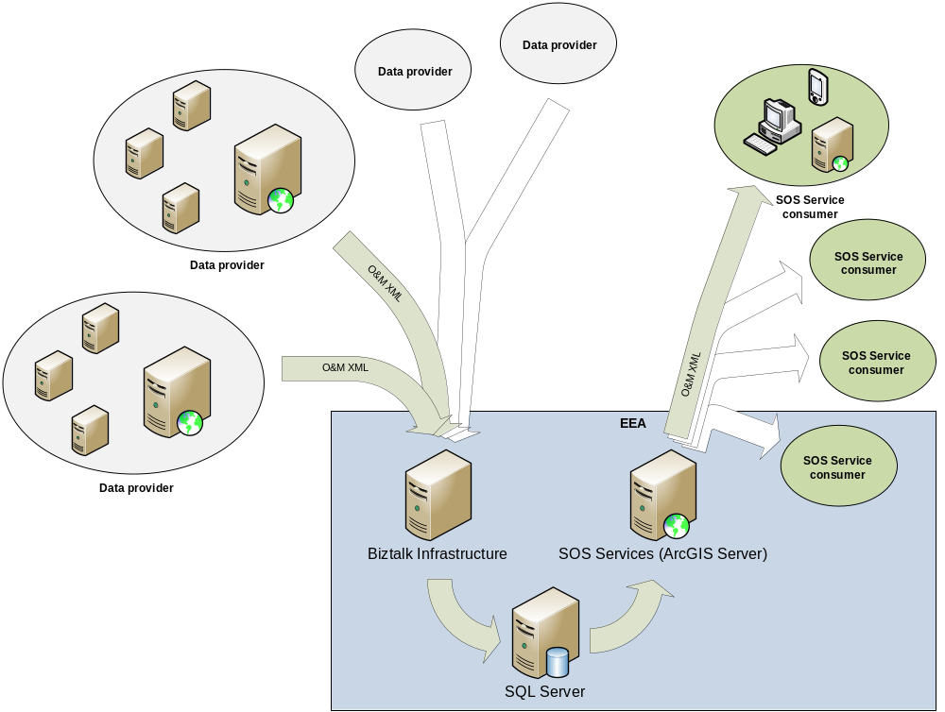
Figure 1: Proposed architecture for integrating the SOS platform into the existing EEA architecture
The text below needs to be aligned with the graphic above with the use of corresponding numbering
For building a SOS platform to be used within EEA and by member states, the following components are envisaged:
- Geodatabase for near real time sensor data: This includes the design of the geodatabase model as well as its implementation within the existing Microsoft SQL Server instances of EEA. Here 52°North will be able to contribute its long lasting experience with database models for SWE and SOS implementations.
- SOS adapter for serving near real time sensor data through ArcGIS Server: This will enable EEA to serve sensor data available in its infrastructure through the SOS interface. This adaptor will extend existing ArcGIS Server instances, i.e. there is no need for specialized types of server implementations. Due to the close collaboration between 52°North, con terra and ESRI Inc. we can assure a development, which takes the most benefit of the ArcGIS Server software.
- SOS adapter for pushing near real time sensor data into the EEA infrastructure: This adapter would be able to receive sensor data from external sources and to push it into the EEA BizTalk infrastructure. Such an adaptor would rely on the transactional interface of the SOS specification so that the internal infrastructure of EEA is hidden and that all data can be delivered to EEA through the same interface. Such an adapter converting from the SOS interface to the BizTalk infrastructure could be partially derived from the 52°North SOS implementation which is in operational use by several customers.
- Harvesting component based on the SOS interface: Such a harvesting component would be able to collect near real time sensor data from SOS servers (e.g. also operated by agencies in the member states). The harvested data will subsequently be pushed into the existing BizTalk infrastructure and into the geodatabases of EEA. For building such a component especially issues like synchronization of sensor data between external SOS instances and the near real time geodatabase of EEA will become a critical aspect. For building such a harvesting mechanism, 52°North will be able to provide the EEA with detailed knowledge and experience (e.g. taking certain elements of the 52°North feeder framework).
- Generic Components and workflows as to manage the flow of near real time sensor data, within the BizTalk environment if EEA. To address this task, Atkins will provide its knowledge about the existing EEA BizTalk infrastructure.
- Set of tools as to support the initialization, maintenance and management of the near real time geodatabases (e.g. setting up a near real time sensor geodatabase, edit and control rules for harvesting and synchronizing with near real time sensor data sources, management of data quality, monitoring service performance etc.)
- Use case specific components and workflows, to be integrated into the BizTalk environment

Use cases
The following should detail specific case cases for each of the actors – how they might use the system.

Information provider
Text 2

Information consumer
Text 3

Eionet
Text

European Environment Agency
Text 2

Global monitoring
Text 3

Business cases
This section details the benefits to each of the actors and identifies their respective goals a SOS system can anble them to deliver. With reference to the use cases in the previous section

Information provider
Text 2

Information consumer
Text 3

Eionet
Text

European Environment Agency
Text 2

Global monitoring
Text 3

Output integration
This section should describe

Specific clients

ArcGIS Server SOS extention
Text here

EyeOnEarth
Text here

Linkages to INSPIRE and reporting mechanisms

Document references
- EEA Strategy paper 2009
https://svn.eionet.europa.eu/projects/SensorWeb/browser/trunk/documenation/2010/Strategy/Environmental%20data%20on%20demand%20%E2%80%93%20enabling%20dynamic%20life%20data%20flows%20with%20Sensor%20Web%20Enablement.doc
- INSPIRE Observation and Measurement specification
http://inspire.jrc.ec.europa.eu/documents/Data_Specifications/D2.9_O&M_Guidelines_V1.0.pdf

